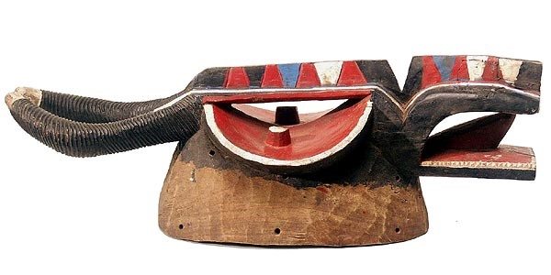

DL 233 (Goli Mask)

ORIGIN: Wan people of Cote d’ Ivoire, West Africa

CULTURE: Baule or Baoulé or Bawule

ORIGINAL NAME: Goli Glin (Ancestral Spirit)

|  |  |
| --- | --- |
|  | label=ImageMedium module=Object id=561862 resolution=medium resolvedModule=Multimedia resolvedId=607271 functionScript=null |
| **Inventory Number:** | RJM 61862 |
| **Title:** | Buffalo mask |
| **Artist/Participant:** | Bwa; cultural attribution; questionable |
|  |  |